

**People’s Democratic Republic of Algeria**

**Ministry of Higher Education and Scientific Research**

**Kasdi Merbah Ouargla University**

**Faculty of new information and telecommunication Technologies**

**Department Of:**

*Informatique*

**LICENCE**

**Submitted by:**

**- BENMOUSSA AHMED REDOUANE**

**- ZIDOURI ABDERRAZZAK**

**- BOUKHECHEBA FARES**

**- BENGHEDIER OUSSAMA**

**- DJAAFAR LECHHEB**

**- BOUGUETTAIA OUADJIH**

**Theme:**

**APPLICATION OF MULTI-SERVICES**

**Supervised by:**

**-Charafeddine Mechalikh**

**Evaluation Date: 05/2023**

2022/2023

# Abstract

Multi-Services application is a comprehensive platform aimed at facilitating and accelerating home maintenance operations. The application offers a wide range of services that meet customers' needs such as electricity, plumbing, paints and others.

Using the app, users can search for the required service and set a convenient date for maintenance. A list of qualified and trusted craftsmen is provided, and users can choose their favorite craftsman based on other users' ratings and past experiences.

The app provides an easy-to-use interface and a convenient user experience. Customers can manage their bookings and track process progress through the app. The payment process is facilitated by various options such as cash payment, credit cards or e-payment services.

The quality of service depends on the selection of specialized and well-trained craftsmen, quality is ensured by customer assessments and their satisfaction. The app works to bring comfort to customers by providing high quality, timely and affordable services.

Using this app, users can save the time and effort it takes to search for separate craftsmen for each type of maintenance work. They can also rely on a reliable and professional service to meet their home maintenance needs.

This app is an ideal solution for those looking to organize and facilitate maintenance in their home, providing them with comfort and confidence in the quality of service provided.

# Resumé

L’application multi-services est une plate-forme complète visant à faciliter et accélérer les opérations de maintenance à domicile. L’application offre un large éventail de services qui répondent aux besoins des clients tels que l’électricité, la plomberie, les peintures et autres.

En utilisant l’application, les utilisateurs peuvent rechercher le service requis et définir une date pratique pour la maintenance. Une liste des craftsmans qualifiés et de confiance est fournie, et les utilisateurs peuvent choisir leur craftsman préféré en fonction des évaluations des autres utilisateurs et des expériences passées.

L’application offre une interface facile à utiliser et une expérience utilisateur pratique. Les clients peuvent gérer leurs réservations et suivre l’avancement du processus au moyen de l’application. Le processus de paiement est facilité par diverses options telles que le paiement en espèces, les cartes de crédit ou les services de paiement électronique.

La qualité du service dépend de la sélection d’craftsmans spécialisés et bien formés, la qualité est assurée par l’évaluation des clients et leur satisfaction. L’application travaille à apporter du confort aux clients en fournissant des services de haute qualité, opportuns et abordables.

En utilisant cette application, les utilisateurs peuvent gagner du temps et des efforts pour rechercher des craftsmans distincts pour chaque type de travail d’entretien. Ils peuvent également compter sur un service fiable et professionnel pour répondre à leurs besoins d’entretien de la maison.

Cette application est une solution idéale pour ceux qui cherchent à organiser et faciliter l’entretien de leur maison, leur offrant confort et confiance dans la qualité du service fourni.

# ملخص

تطبيق متعدد الخدمات هو منصة شاملة تهدف إلى تسهيل وتسريع عمليات الصيانة المنزلية. يقدم التطبيق مجموعة واسعة من الخدمات التي تلبي احتياجات العملاء مثل الكهرباء، السباكة، الدهانات وغيرها.

باستخدام التطبيق، يستطيع المستخدمون البحث عن الخدمة المطلوبة وتحديد موعد ملائم للصيانة. يتم توفير قائمة خاصة بالحرفيين المؤهلين والموثوق بهم، ويمكن للمستخدمين اختيار الحرفي المفضل لديهم استنادًا إلى تقييمات المستخدمين الآخرين وتجاربهم السابقة.

يوفر التطبيق واجهة سهلة الاستخدام وتجربة مريحة للمستخدم. يمكن للعملاء إدارة حجوزاتهم وتتبع تقدم العملية من خلال التطبيق. يتم تسهيل عملية الدفع من خلال خيارات متنوعة مثل الدفع النقدي والبطاقات الائتمانية أو خدمات الدفع الإلكتروني.

تعتمد جودة الخدمة على اختيار حرفيين متخصصين ومدربين بشكل جيد، ويتم ضمان الجودة من خلال تقييمات العملاء ومدى رضاهم. يعمل التطبيق على تحقيق الراحة للعملاء من خلال توفير خدمات عالية الجودة في الوقت المحدد وبأسعار معقولة.

باستخدام هذا التطبيق، يمكن للمستخدمين توفير الوقت والجهد الذي يتطلبه البحث عن حرفيين منفصلين لكل نوع من أعمال الصيانة. كما يمكنهم الاعتماد على خدمة موثوقة ومحترفة لتلبية احتياجات صيانة منازلهم.

يعد هذا التطبيق حلاً مثاليًا لأولئك الذين يبحثون عن تنظيم وتيسير عمليات الصيانة في منازلهم، مما يوفر لهم الراحة والثقة في جودة الخدمة المقدمة.

# Acknowledgements

We would like to express our deep gratitude and thank you very much for your support and valuable guidance throughout this period as our Superintendent. I have been a strong pillar and source of inspiration for us in writing this memo, and we wish to extend our warm thanks for all your efforts. You have guided and motivated us in an exceptional way, and have not hesitated to share your experience and deep knowledge of the subject. We had full confidence in your ability to guide us and help us overcome the various challenges we faced. We have always been dedicated to your task as a supervisor, and you have always been available to listen and answer our questions and queries with patience and interest. It has provided us with the necessary guidance and the opportunity to grow and develop in the area we are studying.

Sommaire

Abstract ii

Resumé iii

ملخص iv

Acknowledgements v

List of Tables vii

List of Figures viii

Introduction 9

Context 9

Problem Statement 9

Objectives and Methodology 9

Chapter 1. State of the Art 11

1.1. E-commerce and Online Service Platforms: 11

1.2. Online Service Delivery and Logistics: 11

1.3. Customer experience and satisfaction: 12

1.4. The Impact of Covid 19 : 12

1.5. The Growth of e-Commerce and Delivery Services in Algeria: 13

1.6. Current and Future Trends: 13

1.7. How to reap the profits: 14

Chapter 2. Market Research 15

2.1. Target Audience: 15

2.2. Competition Analysis: 15

2.2.1. Related Websites: 15

2.2.2. Functionalities and Services that are proposed by These Websites: 16

2.2.3. Their Pros and Cons: 16

2.3. Analysis of Users Needs: 18

2.3.1. The specific needs of tradespeople for their activity: 18

2.3.2. The peculiarities of service offers for craftsmen: 19

2.3.3. The challenges of connecting clients and Craftsmen on a website: 20

2.3.4. Survey: 21

Chapter 3. Design and Development 22

3.1. Definition of Requirements: 22

3.2. Diagrammes: 22

3.2.1. Diagram of Classes: 22

3.2.2. Diagram of Usecase: 23

3.2.3. Diagram of Sequence: 23

3.3. Development Tools: 24

3.4. Front-End: 25

Chapter 4. Tests and Validation 27

4.1. Functionality testing: 27

4.2. Usability testing: 27

4.2.1. Blind Mode: 27

4.2.2. Font Sizes: 28

4.2.3. Screen Sizes: 30

4.3. Scalability potential: 30

Conclusion 31

References 33

Appendices 34

1. Questions for Craftsmen: 34

2. Questions for Owners: 35

3. Functional and Quality Requirements (RFC 2119) : 36

Functional Requirements: 36

Quality Requirements: 37

# List of Tables

Table 1 The Pros and Cons of Websites 20

# List of Figures

Figure 1 The different ways to gain profit 15

Figure 2 Functionalities and Services of Websites Related 17

Figure 3 Statistical Results of Multi-Services Application in Google forms 22

Figure 4 Diagram of Classes 23

Figure 5 Diagram of Usecase 24

Figure 6 Diagram of Sequence 24

Figure 7 Sign in of Multi-Services App 26

Figure 8 Sign up of Multi-Services App 27

Figure 9 Home Page of Multi-Services App 27

Figure 10 Light Mode and Dark Mode of Multi-Services App 29

Figure 11 Font Size of Multi-Services App 30

# Introduction

## Context

Previously, the search for workers was mainly done via print and television or radio advertisements, and it relied heavily on spoken word and the recommendations of friends and family. As technology evolves, it has become easier to search for workers through dedicated apps and websites, where individuals can search for workers through the Internet and find a wide range of qualified workers and available services. The use of technology can provide many advantages for individuals looking for workers, such as saving time and effort in research, access to detailed information on workers and services, and reviews and assessments from other users. On the other hand, the search for workers without the use of technology is still commonly done in some places, via advertisements printed in local newspapers, or advertisements on streets and residential neighbourhoods. The use or non-use of technology in the search for workers can depend on the culture, customs and traditions of the particular region, as well as on the prevalence and availability of technologies in that region.

## Problem Statement

Individuals face many problems and challenges when looking for workers. The most prominent of these are:

1. Difficulty in finding qualified and suitable workers for the required work.
2. Lack of confidence in the quality of services provided by workers, and inability to find evaluations and opinions of other individuals about workers.
3. Difficulty in communicating with workers, scheduling work and paying.

The application solves these problems in a number of ways, as the app enables the search for qualified and suitable workers for the required work easily, and users can see other workers' assessments and opinions.

## Objectives and Methodology

The job search application aims to meet the growing need of individuals to find qualified and suitable workers for the required work, improve the process of communication and coordination with workers, determine work dates and pay.

Developing a multi-service application is a task that needs to consider people's views and needs. There are several steps that can be followed to achieve this:

1. **Research and analysis:** Do research and study on the home maintenance market and similar applications that already exist. Analyze their advantages, strengths, weaknesses and challenges.
2. **Survey:** Design a survey or questionnaire targeting potential home maintenance users. Ask for their views and needs regarding a multi-service application in this area. You can include in the survey questions about the required services, ease of use, payment, user experience, and other important aspects.
3. **Listen to existing customers:** If you have current clients in home maintenance, reach out to them and listen to their opinions and experiences. Ask them what they like about current apps and what they want to see in a new app.
4. **Discussion groups:** Organize discussion groups with potential and existing clients to get more detailed opinions and discuss ideas and proposals. You can use these discussions to clarify the requirements and better determine the services required.
5. **Data Analysis:** Analyze data collected from surveys and discussions to draw trends and priorities. Try to identify the most in-demand services, preferred features and common problems faced by customers.
6. **Design & Implementation:** Based on previous analysis, design and develop multi-service application in home maintenance. Try to include features and services that customers look forward to based on their opinions and needs.
7. **Continuous improvement:** Once the app is launched, continue to collect user feedback and learn from it for continuous improvement. You can organize periodic reviews, analyze feedback and communicate with customers to understand how the app can be improved and better meet their needs.

The multi-service application should be designed in the field of home maintenance based on people's opinions and needs. By communicating with and listening to users, you can provide an experience that meets their expectations and achieves the success of the app.

# Chapter 1. State of the Art

## 1.1. E-commerce and Online Service Platforms:

E-commerce and online service platforms are web-based systems that allow businesses and individuals to conduct transactions and offer services over the internet. These platforms are increasingly popular due to their convenience, accessibility, and ability to reach a global audience.

E-commerce platforms provide different companies a sales platform to access global markets. The relationship between the e-commerce platform and the companies making online sales through the e-commerce platform creates several challenges[1]. Some popular e-commerce platforms include Amazon, eBay, Shopify, and WooCommerce.

Online service platforms, on the other hand, enable businesses and individuals to offer their services online, such as freelancing, consulting, tutoring, and more. Some popular online service platforms include Upwork, Fiverr, Airbnb, and Uber. Online, pure-labor service platforms (e.g., Zeel, Amazon Home Services, Freelancer.com) represent a multibillion-dollar market [2].

Both e-commerce and online service platforms have revolutionized the way businesses operate and interact with their customers. They have made it easier for small businesses and independent professionals to establish an online presence, reach a wider audience, and compete with larger companies.

## 1.2. Online Service Delivery and Logistics:

Online service delivery and logistics refer to the process of delivering services to customers through digital channels, such as the internet, mobile applications, and other digital platforms. It involves a range of activities, including order processing, inventory management, shipping, and customer support.In the context of online service delivery, logistics play a critical role in ensuring that services are delivered to customers in a timely and efficient manner. For example, in the case of an online tutoring service, logistics may include scheduling and coordinating sessions with students, managing tutor availability, and ensuring that students receive the necessary materials and support.In addition, Governments around the world are facing the challenge of responding to increased expectations by their customers with regard to public service delivery. Citizens, for example, expect governments to provide better and more efficient electronic services on the Web in an integrated way. Online portals have become the approach of choice in online service delivery to meet these requirements and become more customer-focussed [3].

To ensure successful online service delivery and logistics, businesses must invest in technology, processes, and personnel to manage the various aspects of the service delivery process. They must also focus on providing excellent customer support, as online customers expect fast and responsive service, and may have a low tolerance for errors or delays.

## 1.3. Customer experience and satisfaction:

Customer experience is a key marketing concept, yet the growing number of studies focused on this topic has led to considerable fragmentation and theoretical confusion[4].Customer experience and satisfaction are critical for the success of any online platform, whether it is an e-commerce platform, an online service platform, or any other digital service. Providing a positive customer experience and ensuring customer satisfaction can help businesses build trust and loyalty, encourage repeat business, and attract new customers through word-of-mouth referrals. Here are some key factors that contribute to customer experience and satisfaction in online platforms:

1. **User-friendly interface:** The platform should have an easy-to-use interface that is intuitive and accessible to all users, regardless of their technical knowledge.
2. **Clear and concise information:** The platform should provide clear and concise information about the products or services offered, including pricing, features, and benefits.
3. **Fast and responsive service:** Customers expect fast and responsive service, including quick response times to inquiries, prompt order processing, and fast shipping.
4. **Reliable and secure transactions:** The platform should ensure that all transactions are secure, and that customer data is protected from unauthorized access or theft.
5. **Effective customer support:** The platform should offer responsive and effective customer support, including multiple channels for communication (such as chat, email, or phone), and knowledgeable support staff who can help resolve any issues or concerns.

By focusing on these factors, businesses can create a positive customer experience and improve customer satisfaction in their online platforms. This, in turn, can help them build a loyal customer base and drive growth in their business.

## 1.4. The Impact of Covid 19 :

Covid-19 has had a significant impact on many industries and sectors, including the mobile app industry. The pandemic has led to an increased reliance on digital technology and the shift of many daily activities to the digital world.

In terms of mobile apps, the widespread adoption of remote work and the need to stay at home has led to an increased demand for mobile apps that facilitate communication, remote work, and online business management. The pandemic has also led to strict restrictions on movement and public gatherings, which has made many people rely on delivery and shipping apps to purchase essential goods and other products.

The importance of mobile apps has increased in the current circumstances as they meet the needs of customers in accessing products and services online. The demand for mobile apps is expected to continue to increase, including delivery and logistics apps, remote work and learning apps, and apps that facilitate communication and connectivity in the digital world.

## 1.5. The Growth of e-Commerce and Delivery Services in Algeria:

E-commerce and delivery services have seen significant growth in Algeria in recent years, driven by several factors. One of the main drivers of this growth is the increasing availability of internet and mobile technology across the country, which has made it easier for consumers to shop online and access delivery services.In addition, the COVID-19 pandemic has accelerated the adoption of e-commerce and delivery services, as many consumers have turned to online shopping and delivery as a safer and more convenient option. This has also led to an increase in the number of businesses offering e-commerce and delivery services, as they seek to adapt to the changing consumer behavior and preferences. The Algerian e-commerce market is growing, but it is relatively limited in scope. According to the trade group GIE Manistique, there were 291 online retailers in Algeria by the end of 2022 They processed approximately 22 million payments worth $120 million in 2022 [5].

The Algerian government has also taken steps to support the growth of e-commerce and delivery services in the country, including the development of e-commerce regulations and initiatives to improve the logistics infrastructure. For example, the government has launched several programs to support e-commerce businesses and provide them with access to financing and training. Despite the growth potential, e-commerce and delivery services in Algeria still face some challenges, including a lack of trust among consumers and businesses, limited payment options, and logistical challenges in delivering products across the country. However, with the right support and infrastructure, the sector is poised for continued growth and development in the coming years.

## 1.6. Current and Future Trends:

Mobile apps have become an essential part of our daily lives, and the industry continues to evolve and grow rapidly. Here are some current and future trends for mobile apps:

**Artificial Intelligence (AI) and Machine Learning (ML) – AI and ML:** are increasingly being integrated into mobile apps, providing personalized experiences for users, predictive insights, and automating tasks.

**Mobile Payments** – The use of mobile payments continues to grow, with more users opting to pay for products and services through their mobile devices.

**Wearable Devices** – The integration of mobile apps with wearable devices like smartwatches and fitness trackers is increasing, providing users with access to real-time information and personalized experiences.

**Mobile-first approach:** is a design strategy that involves creating a website or application with a primary focus on mobile devices. It means that the design and development process starts with the smallest screen size (usually a mobile device) and then scales up to larger screen sizes such as tablets, laptops, and desktops.

In the future, we can expect to see continued growth and innovation in the mobile app industry, with an increasing focus on providing personalized experiences, improving security and privacy, and the development of new technologies like blockchain and edge computing.

## 1.7. How to reap the profits:

There are several ways to generate profit from a mobile app. Here are some common strategies (See ):

Figure 1 The different ways to gain profit

It is important to note that the success of a mobile app depends on various factors, including the quality of the app, user engagement, and the effectiveness of the chosen revenue model.

# Chapter 2. Market Research

## 2.1. Target Audience:

The target audiences of the services search app vary based on the type of services provided by the app and the location of the application and the availability of these services in the target area. However, some potential target audiences include:

1. **Individual users:** These audiences can be targeted to meet their personal needs in the search for diverse services such as maintenance services.
2. **Small Business:** Small businesses can use the service search app to find good service providers to meet their needs such as advertising business, managing appointments and communicating with customers and potential customers.
3. **Freelancers:** Freelancers can use the service search app to find jobs, communicate with their customers and manage their financial accounts and bills.
4. **Non-governmental organizations (NGOs):** NGOs can use the service search app to improve the quality of services they provide to citizens.
5. **Large companies:** Large companies can use the service search app to find good service providers and to manage their financial accounts and other operations.

The application targets a diverse audience of users, institutions and governments, depending on the type of services provided and the needs of the target audience in the specific region. Targeting a target audience requires a comprehensive market analysis and a deep understanding of customers' needs and requirements. Services and interface must be designed in a way that meets the needs of the target audience and features easy use, useful functions, security and quality. The owner of the application must identify the target audience and effectively meet their needs and requirements.

## 2.2. Competition Analysis:

### 2.2.1. Related Websites:

There are many websites that are related to multi-service apps, depending on the specific services that the app offers. Here are some examples: **Thumbtack, TaskRabbit, Fiverr, Upwork, Handy, Zocdoc and Rover.**

These are just a few examples of websites that are related to multi-service apps. Depending on the specific services offered by the app, there may be many more relevant websites to consider.

### 2.2.2. Functionalities and Services that are proposed by These Websites:

Here are some of the functionalities and services that are proposed by the websites related to multi-service apps mentioned earlier (See Figure 2):

Figure 2 Functionalities and Services of Websites Related

The functionalities and services offered by these websites focus on providing a platform for users to connect with service providers, view information about those providers, and book services directly through the app. Many of these platforms also incorporate reviews and ratings from previous customers to help users make informed decisions about which service provider to hire.

### 2.2.3. Their Pros and Cons:

Here are some pros and cons of the websites related to multi-service apps mentioned earlier (See Table 1):

Table 1 The Pros and Cons of Websites

|  |  |  |
| --- | --- | --- |
| Name of Websites | Pros | Cons |
| Thumbtack | - Wide range of services offered, making it a one-stop-shop for many different types of service needs.  - Ability to view profiles of service providers, read reviews, and compare quotes before making a hiring decision.  - Easy to use platform with a simple interface. | - Fees can be high for service providers, which may result in higher prices for customers.  - Not all service providers are vetted or verified, so there may be quality control issues. |
| TaskRabbit | - Large network of Taskers available for a variety of different tasks and services.  -Ability to view profiles of Taskers, read reviews, and book appointments directly through the app.  Easy to use platform with a simple interface. | -Fees can be high for service providers, which may result in higher prices for customers.  -Quality control issues with some Taskers not meeting expectations or providing poor service. |
| Fiverr | -Wide range of services offered, with freelancers available for many different types of projects.  -Ability to view profiles of freelancers, read reviews, and communicate directly with sellers to place orders.  - Competitive pricing and quick turnaround times for many services. | -Quality control issues with some freelancers not delivering work that meets expectations or providing poor service.  -Some services may be of low quality due to low pricing and a large number of sellers. |
| Upwork | -Large network of freelancers available for a wide range of services, with a focus on professional and technical services.  -Ability to search for freelancers based on skills and experience, view profiles and portfolios, and communicate directly with freelancers through the app.  -Secure payment system and escrow services to protect both clients and freelancers. | -Fees can be high for freelancers, which may result in higher prices for clients.  -Quality control issues with some freelancers not meeting expectations or providing poor service. |
| Handy | -Focused specifically on home services, with a wide range of services available.  -Ability to view profiles of service providers, read reviews, and book appointments directly through the app.  -Easy to use platform with a simple interface. | -Fees can be high for service providers, which may result in higher prices for customers.  -Quality control issues with some service providers not meeting expectations or providing poor service. |
| Zocdoc | -Ability to find and book appointments with healthcare providers in a variety of specialties.  -Ability to search for providers based on location, specialty, and insurance coverage.  -Easy to use platform with a simple interface. | -Not all healthcare providers are available on the platform.  -Some users have reported issues with appointment availability and long wait times. |
| Rover | -Focused specifically on pet services, with a wide range of services available.  -Ability to search for sitters based on location, availability, and services offered, read reviews, and book services directly through the app.  -Easy to use platform with a simple interface. | -Fees can be high for service providers, which may result in higher prices for customers.  -Quality control issues with some service providers not meeting expectations or providing poor service. |

## 2.3. Analysis of Users Needs:

### 2.3.1. The specific needs of tradespeople for their activity:

Tradespeople have specific needs related to their activity that must be met in order to effectively run their business and provide high-quality services to their clients. Here are some examples of the specific needs of tradespeople:

1. **Tools and Equipment:** Tradespeople require specific tools and equipment to perform their job. These tools may include power tools, hand tools, measuring devices, and safety equipment. It is essential for tradespeople to have reliable and high-quality tools in order to perform their job effectively and safely.
2. **Materials and Supplies:** Tradespeople also require specific materials and supplies to perform their job. These may include building materials, electrical components, plumbing fixtures, and other items needed to complete a job. It is important for tradespeople to have access to reliable suppliers and high-quality materials in order to provide quality work to their clients.
3. **Transportation:** Tradespeople typically need a reliable means of transportation in order to travel to job sites and transport tools and materials. Many tradespeople use a work vehicle, such as a truck or van, to transport their tools and equipment to job sites.
4. **Insurance:** Tradespeople need insurance to protect themselves and their business. This may include liability insurance, workers' compensation insurance, and vehicle insurance. Insurance can help protect tradespeople from financial loss in the event of an accident or injury.
5. **Marketing and Promotion:** Tradespeople need to market and promote their services in order to attract new clients and grow their business. This may include creating a website, building a social media presence, and networking with other professionals in their industry.
6. **Administrative Tasks:** Tradespeople also have administrative tasks that must be completed, such as invoicing, record keeping, and scheduling appointments. Many tradespeople use software or apps to help them manage these tasks and stay organized.

Tradespeople require a range of tools, equipment, materials, and administrative support in order to effectively run their business and provide high-quality services to their clients. It is important for tradespeople to identify their specific needs and invest in the necessary resources to ensure their success.

### 2.3.2. The peculiarities of service offers for craftsmen:

Craftsmen, such as carpenters, painters, plumbers, electricians, and other skilled tradespeople, often have unique service offers that distinguish them from other service providers. Here are some of the peculiarities of service offers for Craftsmen:

1. **Customized Services:** Craftsmen often offer customized services that are tailored to the specific needs and preferences of their clients. For example, a carpenter may offer custom-made furniture or cabinetry, while a painter may offer custom color matching and design services.
2. **High-Quality Craftsmanship:** Craftsmen are known for their high-quality craftsmanship and attention to detail. They take pride in their work and strive to provide the best possible service to their clients.
3. **Specialized Skills and Expertise:** Craftsmen often have specialized skills and expertise in their trade, which allows them to provide unique and high-quality services. For example, an electrician may specialize in installing solar panels, while a plumber may specialize in installing high-end fixtures.
4. **Personalized Customer Service:** Craftsmen often provide personalized customer service and build strong relationships with their clients. They take the time to listen to their clients' needs and preferences and work closely with them to achieve their goals.
5. **Local and Sustainable Materials:** Craftsmen often use locally sourced and sustainable materials in their work, which helps support local businesses and reduce their environmental impact.

The peculiarities of service offers for Craftsmen are cantered around providing high-quality, customized services that meet the unique needs and preferences of their clients. They often rely on specialized skills and expertise, personalized customer service, and local and sustainable materials to set themselves apart from other service providers.

## 2.3.3. The challenges of connecting clients and Craftsmen on a website:

Connecting clients and Craftsmen on a website can be a challenging process due to several factors. Here are some of the challenges involved:

1. **Trust and Safety:** One of the biggest challenges of connecting clients and Craftsmen on a website is establishing trust and ensuring safety. Clients need to feel confident that they are working with a reputable and trustworthy craftsman, while Craftsmen need to feel secure in their transactions and interactions with clients. Building a safe and trustworthy platform requires rigorous screening and verification processes for both clients and Craftsmen.
2. **Communication:** Effective communication is essential for connecting clients and Craftsmen on a website. However, language barriers, cultural differences, and time zone differences can make communication challenging. A well-designed platform should include features that facilitate communication, such as chat, video conferencing, and translation tools.
3. **Technical Issues:** Technical issues such as website downtime, slow loading times, and bugs can prevent clients and Craftsmen from connecting and conducting business on the platform. A reliable and user-friendly website that is easy to navigate is crucial for facilitating successful transactions between clients and Craftsmen.
4. **Competition:** Competition from other similar websites or platforms can make it challenging to attract and retain clients and Craftsmen. Building a strong brand identity, offering unique features or services, and providing exceptional customer service can help a platform stand out from its competitors.
5. **Payment Processing:** Payment processing can be a challenge when connecting clients and Craftsmen on a website. A reliable and secure payment system that supports multiple payment methods and currencies is essential. Additionally, the platform must ensure that payments are processed quickly and efficiently to avoid delays or disputes.

Connecting clients and Craftsmen on a website involves many challenges, including establishing trust and safety, effective communication, technical issues, competition, and payment processing. Addressing these challenges requires a well-designed platform with robust features and a user-friendly interface, as well as rigorous screening and verification processes for both clients and Craftsmen.

### 2.3.4. Survey:

In this part we wanted to take the opinion of the community by asking us a set of questions showing us the tendencies of people and the nature of the work to be added, so these results are described in (See Figure 3):

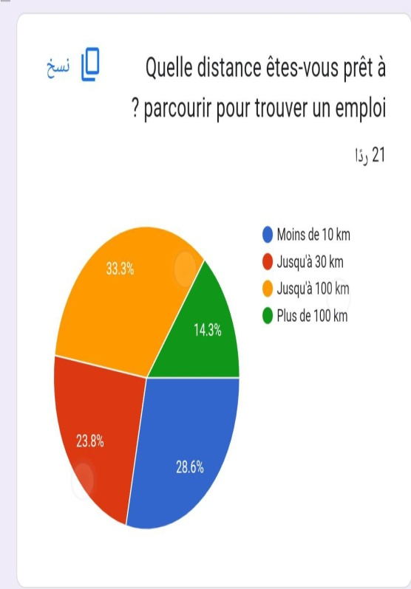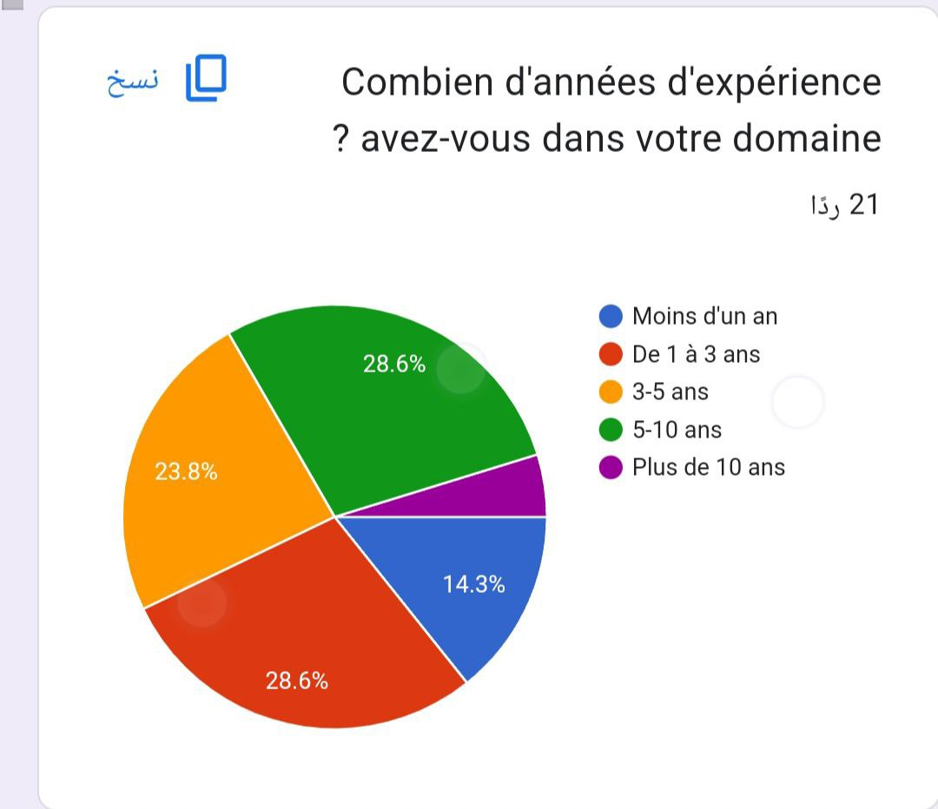

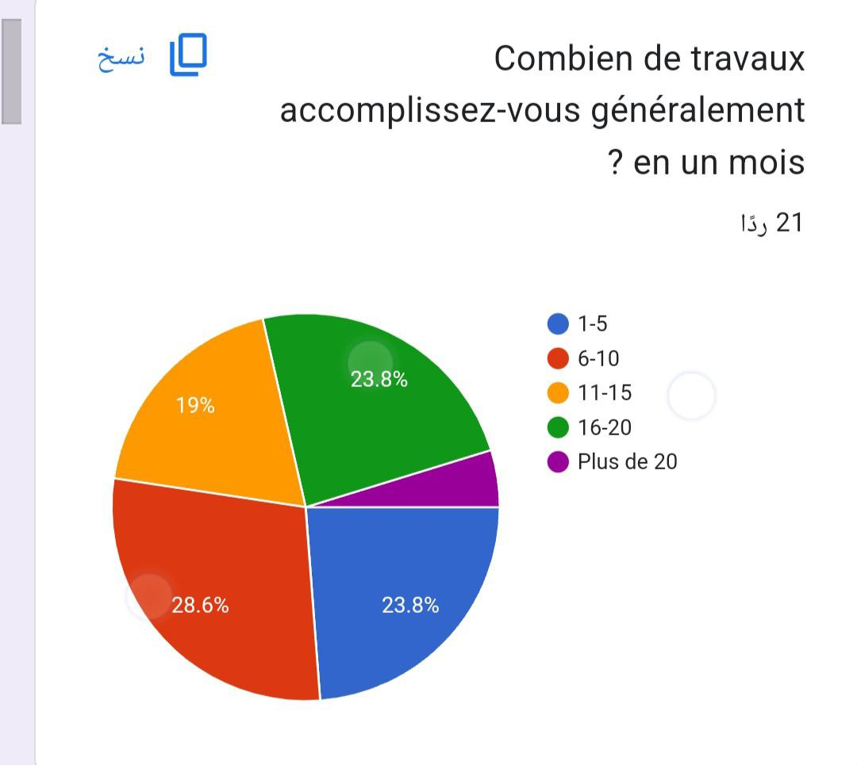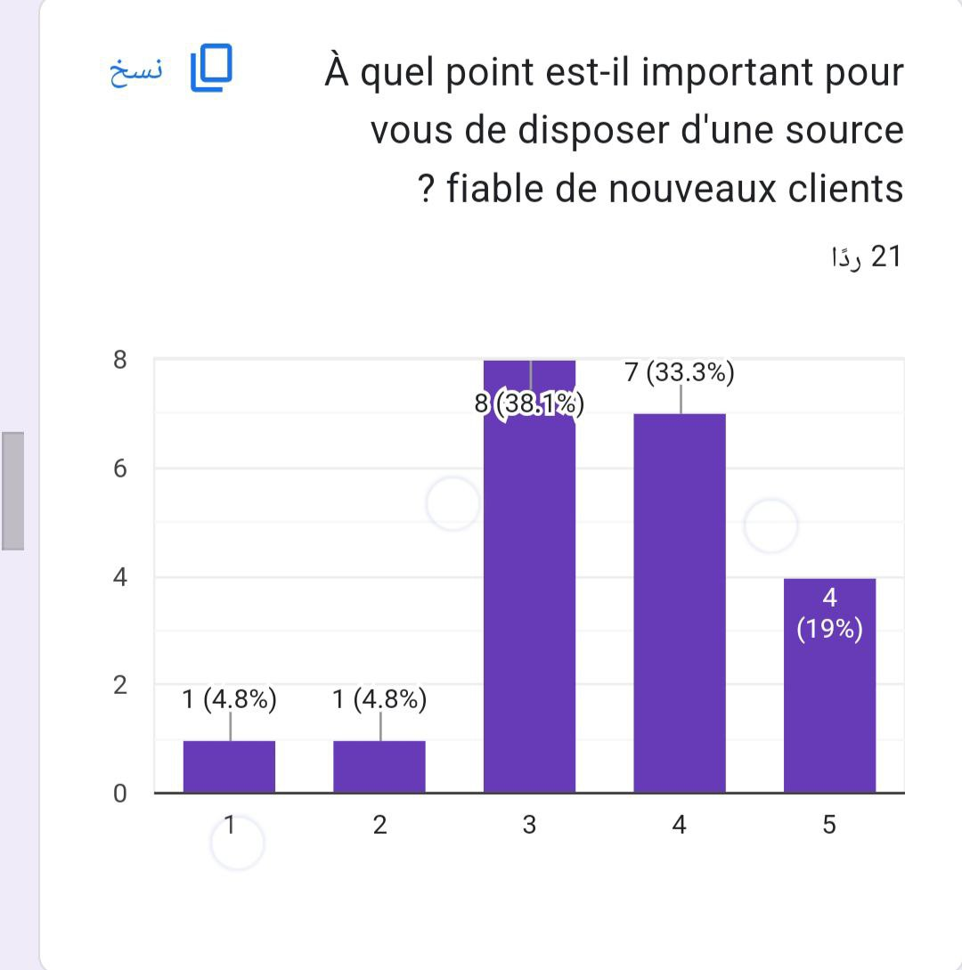

Figure 3 Statistical Results of Multi-Services Application in Google forms

# Chapter 3. Design and Development

## 3.1. Definition of Requirements:

Requirements refer to the set of specifications, capabilities, functionalities, and features that a product or system must have to meet the needs of its users or stakeholders. According to RFC 2119 [6], and based on the conducted market research we defined a set of Functional and Quality Requirements for our application (refer to Appendix ‎3).

## 3.2. Diagrammes:

### 3.2.1. Diagram of Classes:

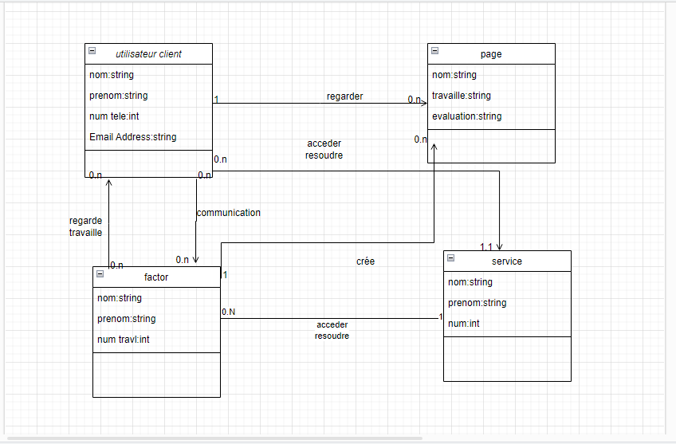

Figure 4 Diagram of Classes

### 3.2.2. Diagram of Usecase:

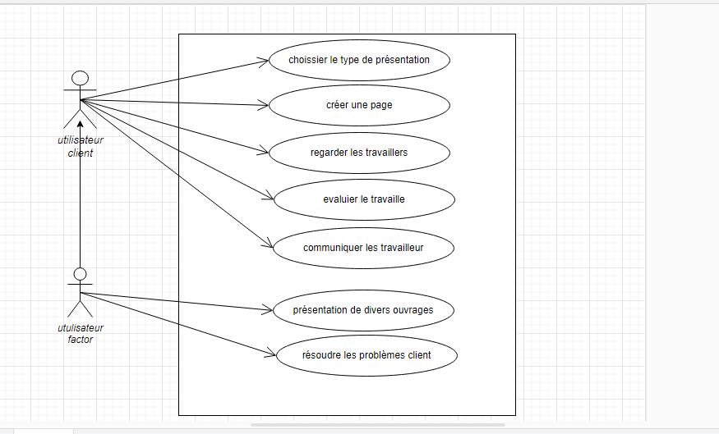

Figure 5 Diagram of Usecase

### 3.2.3. Diagram of Sequence:

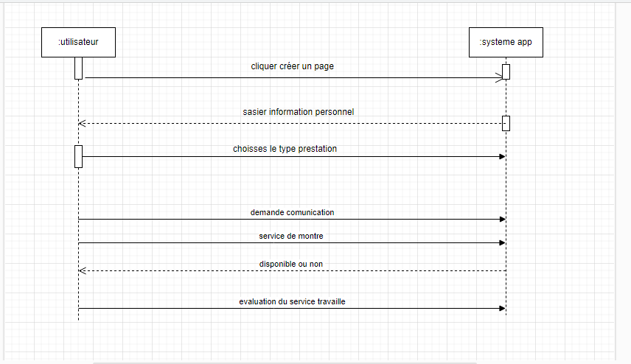

Figure 6 Diagram of Sequence

## 3.3. Development Tools:

Development tools are software programs or platforms that developers use to design, code, test, and deploy software applications. These tools are designed to simplify and automate various aspects of the software development process, making it more efficient and effective. Here are some common development tools used by software developers:

1. **Integrated Development Environments (IDEs):** IDEs are software applications that provide a comprehensive development environment for coding, debugging, and testing software applications. They typically include features such as code editors, code completion, debugging tools, and built-in compilers. For example: Android Studio.
2. **Version Control Systems (VCS):** VCS are software tools used to manage changes to source code over time. They allow multiple developers to collaborate on the same codebase and keep track of changes made to the code. Some popular VCS tools include Git, SVN, and Mercurial.
3. **Firebase:** is a popular mobile and web application development platform provided by Google. It offers a suite of cloud-based services and tools that help developers build, manage, and scale their applications more efficiently. Firebase provides both backend infrastructure and ready-to-use features that simplify common development tasks.
4. **Flutter:** It is an open-source UI (User Interface) software development kit created by Google. It is used for building natively compiled applications for mobile, web, and desktop from a single codebase.
5. **Figma:** is an online design and collaboration tool used in the design, processing and sharing of user interfaces, website design and graphic applications. Figma is a cloud platform that works over the browser, allowing designers and design teams to work and collaborate on projects easily without having to download or install software on their devices.
6. **Dart:** is a programming language developed by Google. It was first released in 2011 and is designed to be a general programming language used in the development of web, mobile and desktop applications. Dart is a powerful, versatile language with several features.

Development tools are essential for software developers to design, code, test, and deploy software applications more efficiently and effectively. These tools help developers automate various aspects of the development process, enabling them to focus on creating high-quality software that meets the needs of their users and stakeholders.

Haut du formulaire

## Front-End:

In this part we will show photos of the application from inside (See Figures 7, 8 and 9):

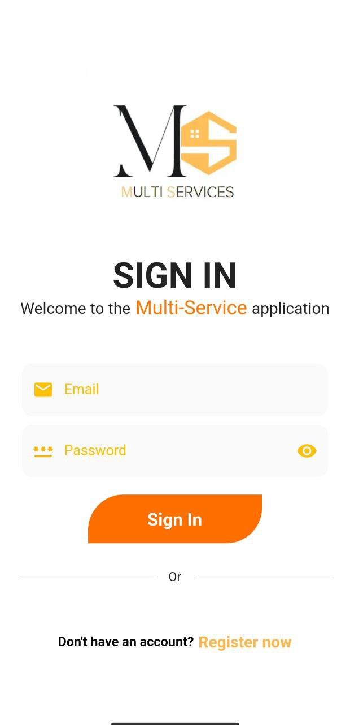

Figure 7 Sign in of Multi-Services App

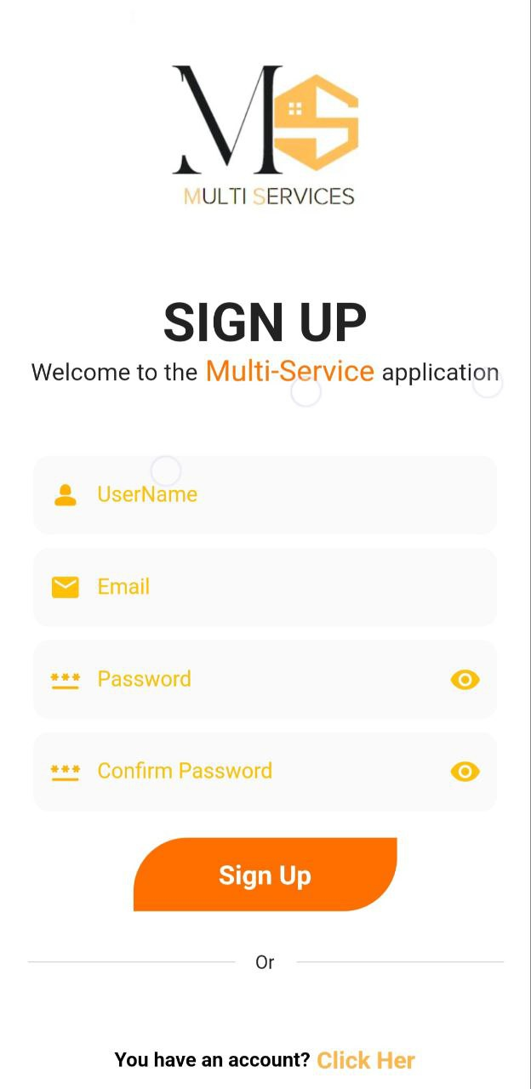

Figure 8 Sign up of Multi-Services App

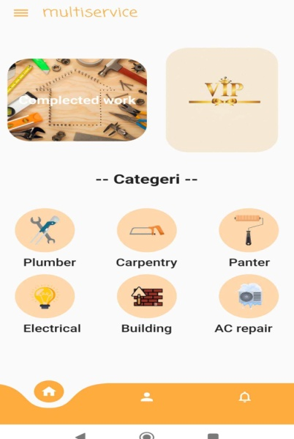

Figure 9 Home Page of Multi-Services App

# Chapter 4. Tests and Validation

## 4.1. Functionality testing:

Functionality testing is a type of software testing that evaluates whether a software application or system meets its functional requirements and specifications. The goal of functionality testing is to ensure that the application or system performs the intended functions and meets the needs of its users. (See Functional Requirements).

## 4.2. Usability testing:

Usability testing is a method of evaluating the usability and user experience of a product, such as a website or software application, by observing and collecting feedback from real users. The goal of usability testing is to identify any usability issues or problems that may hinder user satisfaction or task completion and to collect feedback that can be used to improve the product:

### 4.2.1. Blind Mode:

Blind Mode (Color blindness): is a condition that affects a person's ability to see and distinguish certain colors or distinguish them poorly. Although many people with color blindness are able to handle colors in general, we must take into account the design of the app so that it is easy to read and use for these people as well, and for further clarification (See Figure 10):

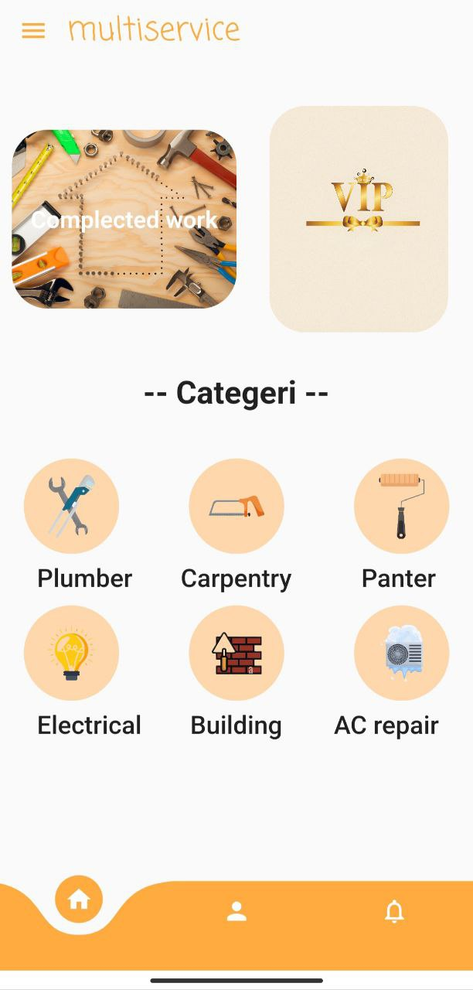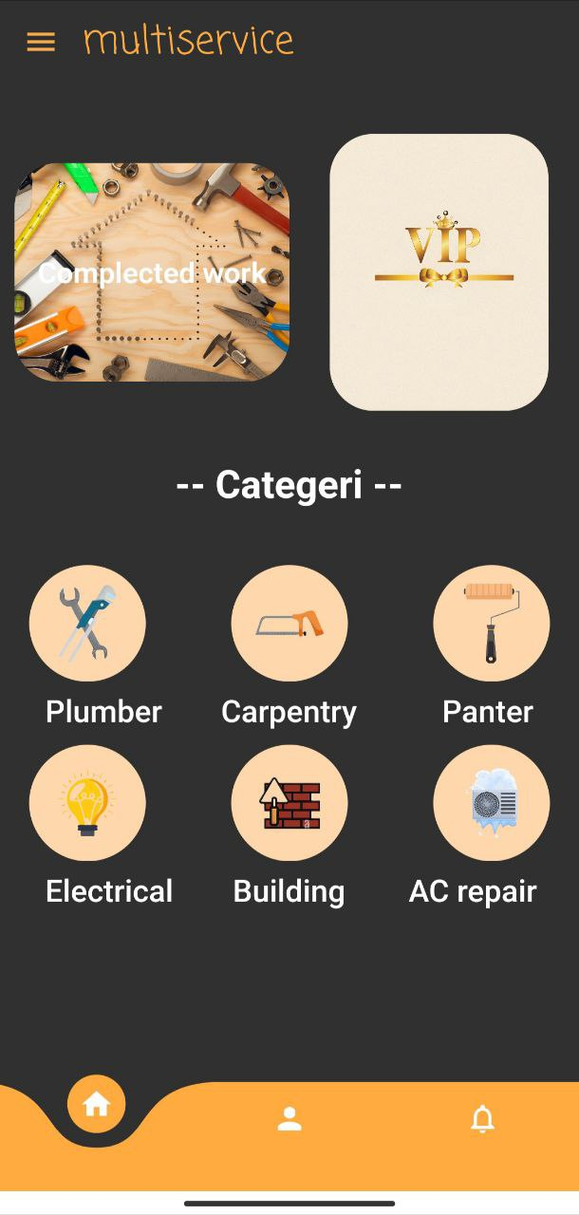

Figure 10 Light Mode and Dark Mode of Multi-Services App

### 4.2.2. Font Sizes:

When developing a multi-service application, there are no specific sizes of lines that can be adopted once and for all. Choosing the size and type of lines depends on several factors, including the overall design of the application, the target and the user experience. Focused on easy reading, the font should be clear and easy to read in proportion to the content displayed by the app... (See Figure 11):

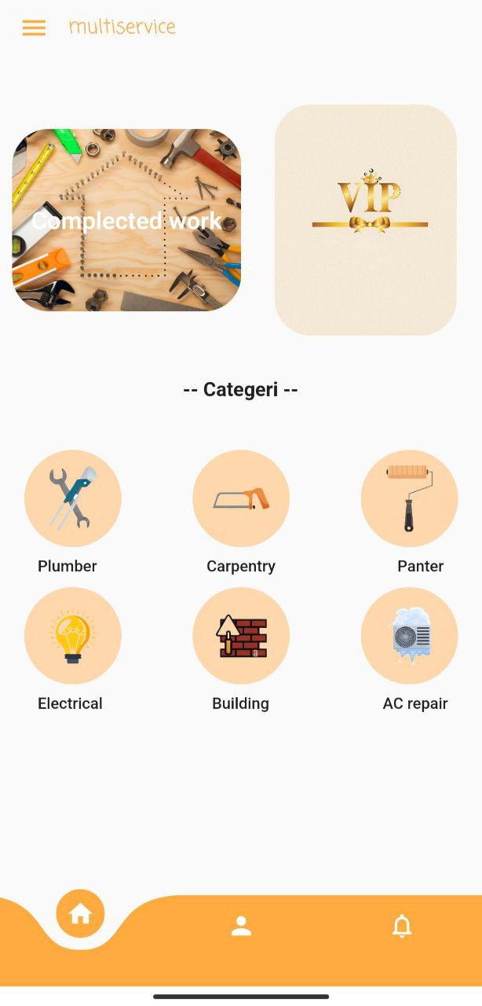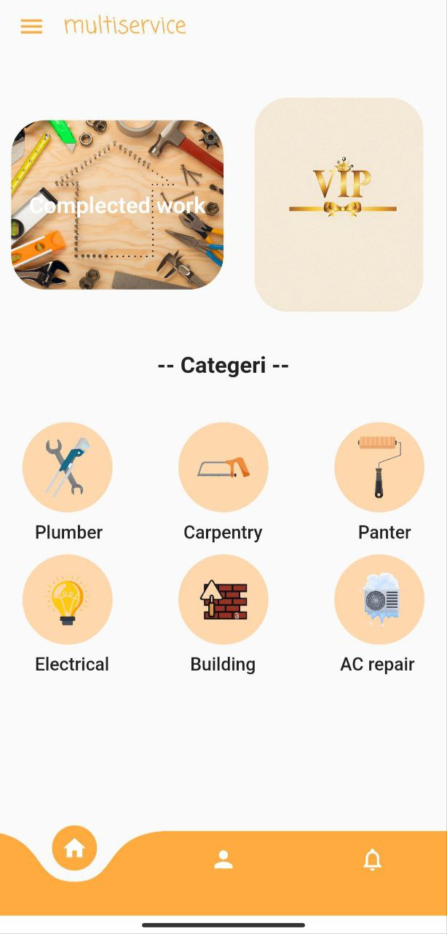

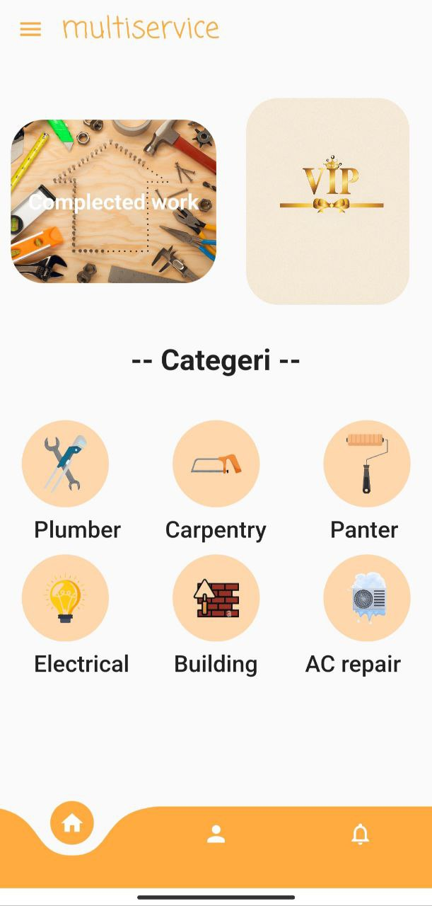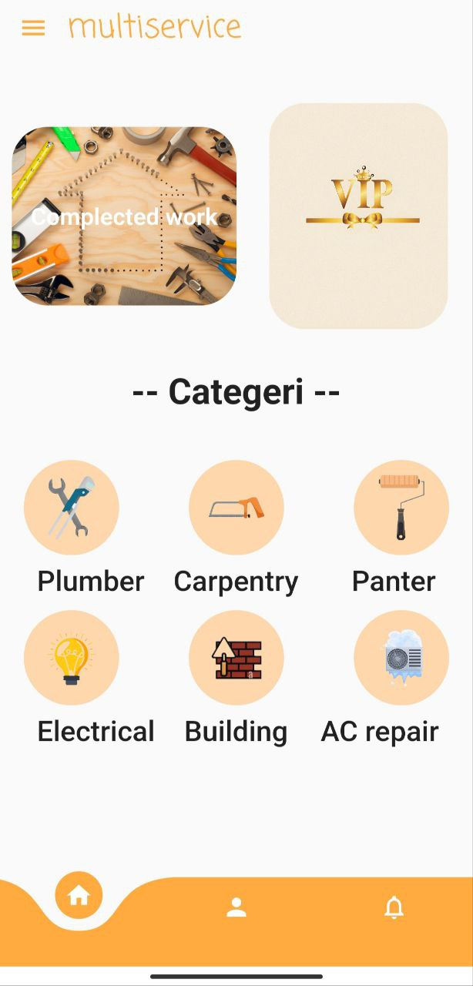

Figure 11 Font Size of Multi-Services App

### 4.2.3. Screen Sizes:

The screen size of a multi-service application can vary according to the device used to run the application. However, common screen sizes for mobile devices include:

1. **Smartphones:** Smartphone screen sizes range from about 4 inches (10 cm) to more than 6.7 inches (17 cm) in some modern devices.
2. **Tablets (Tablet):** Many screen sizes are available for tablets, from about 7 inches (18cm) to 12 inches (30cm) or more.
3. **Laptops:** Laptops screen sizes range from about 11 inches (28 cm) down to 17 inches (43 cm) or more.
4. **Personal computers (desktops):** In the case of computers, screens ranging from 19 inches (48 cm) to 27 inches (68 cm) or larger can be used.

It is important to design a multi-service application to be compatible and accessible on the various screen sizes mentioned above.

## 4.3. Scalability potential:

The potential for expansion refers to the app's ability to grow and expand over time, both in terms of the number of users and the scope of services provided. Application expansion potential will depend on different factors, such as user base «Firebase ".

From a technical point of view, the app must be designed to handle a large number of users and transactions, without encountering significant performance issues or crashes. This will require a scalable technical infrastructure that can be easily improved as needed, which is the reason why firebase has been used.

# Conclusion

The app is intended to provide a platform for Craftsmen to showcase their services and connect with potential clients. It should also offer clients the ability to search for and hire Craftsmen, as well as rate and provide feedback on their services. The problem is that clients often struggle to find reliable and skilled Craftsmen for various services, while Craftsmen may find it challenging to connect with potential clients. The multi-service app aims to address this problem by providing a platform for clients and Craftsmen to connect and collaborate.

The contributions of this project could be significant for both clients and Craftsmen, as well as the broader community. Here are a few potential contributions:

1. **Improved accessibility:** The app would provide clients with easier access to a wide range of reliable Craftsmen and services. This could help to reduce the time and effort required to find suitable Craftsmen and services, making it more convenient and accessible for clients.
2. **Increased visibility:** Craftsmen would have an opportunity to showcase their services and build their client base through the app. This could help to increase their visibility and improve their chances of finding new clients and opportunities.
3. **Enhanced reliability:** The app could improve the reliability of the services provided by Craftsmen by providing a platform for clients to rate and provide feedback on their services. This could help to establish trust and transparency between clients and Craftsmen, which could lead to more positive experiences and better outcomes for both parties.
4. **Increased job opportunities:** By connecting Craftsmen with more clients and opportunities, the app could help to create new job opportunities and promote economic growth in the community.

The project could contribute to improving the efficiency and effectiveness of the craftsman services industry by providing a platform for clients and Craftsmen to connect and collaborate, which could have a positive impact on both clients and Craftsmen, as well as the broader community.

There are a few limitations and perspectives that should be considered for this project:

1. **Limited reach:** The app may be limited in its reach if it does not have a significant number of users or if it is not marketed effectively. This could limit its effectiveness in connecting clients with Craftsmen and reducing the challenges of finding reliable services.
2. **Technical challenges:** Developing and maintaining a multi-services app can be technically challenging and may require significant resources, such as time, money, and expertise. Ensuring that the app is user-friendly, reliable, and secure could also be a challenge...
3. **Handling a large base of Craftsmen:** You must build a long-term relationship with a large base of home Craftsmen and keep providing high quality services. It can be difficult to manage and coordinate work dates and ensure the availability of Craftsmen on time.
4. **Expansion and adaptation:** As the market evolves and new challenges emerge, you must have the ability to expand and adapt to variables and meet the needs of users and Craftsmen continuously.

From a business model standpoint, the app should be designed to generate revenue and sustain its operations over time. This could involve various monetization strategies, such as charging a commission on transactions or offering premium services for a fee.

From the user base point of view, the app must be designed to attract and retain a large and diverse user base, including customers and craftsmen from different regions and communities. This will require a marketing strategy targeting different user groups and a user interface that is user-friendly and accessible to a wide range of users.

In terms of scalability potential, the app could have significant potential for growth and expansion over time. The craftsman services industry is a large and diverse market, with significant opportunities for new entrants. As the app attracts more users and expands its range of services, it could become a leading platform for connecting clients with reliable and skilled Craftsmen .The scalability potential of the app will depend on various factors, such as the technical infrastructure, user base, and business model. By addressing these factors effectively, the app could have significant potential for growth and expansion over time.

# References

[1] M. Hasiloglu و O. Kaya, "An analysis of price, service and commission rate decisions in online sales made through E-commerce platforms", *Comput. Ind. Eng.*, م 162, ص 107688, ديسمبر 2021, doi: 10.1016/j.cie.2021.107688.

[2] Q. (Kris) Zhou, B. J. Allen, R. T. Gretz, و M. B. Houston, "Platform Exploitation: When Service Agents Defect with Customers from Online Service Platforms", *J. Mark.*, م 86, عدد 2, ص 105–125, مارس 2022, doi: 10.1177/00222429211001311.

[3] T. Kohlborn, S. Weiss, J. Poeppelbuss, A. Korthaus, و E. Fielt, "Online Service Delivery Models – An International Comparison in the Public Sector", *ACIS 2010 Proc.*, يناير 2010, [مباشر على الإنترنت]. موجود في: https://aisel.aisnet.org/acis2010/30

[4] L. Becker و E. Jaakkola, "Customer experience: fundamental premises and implications for research", *J. Acad. Mark. Sci.*, م 48, عدد 4, ص 630–648, يوليو 2020, doi: 10.1007/s11747-019-00718-x.

[5] 1, "Algeria - eCommerce". https://www.trade.gov/country-commercial-guides/algeria-ecommerce (تاريخ الوصول 18 مايو، 2023).

[6] S. O. Bradner, "Key words for use in RFCs to Indicate Requirement Levels", Internet Engineering Task Force, Request for Comments RFC 2119, مارس 1997. doi: 10.17487/RFC2119.

# Appendices

## Questions for Craftsmen:

1. What types of home maintenance services do you specialize in?
2. How many years of experience do you have in the field of home maintenance?
3. What certifications or qualifications do you possess related to home maintenance?
4. Can you provide references or examples of your previous work in home maintenance?
5. How do you ensure the quality of your work and customer satisfaction?
6. Are you familiar with modern tools and techniques used in home maintenance?
7. How do you handle unexpected challenges or complications that may arise during a maintenance project?
8. Do you have any specific areas of expertise within home maintenance (e.g., plumbing, electrical, carpentry)?
9. How do you stay updated with the latest trends and advancements in home maintenance practices?
10. Are you licensed and insured to perform home maintenance services?
11. What is your availability for home maintenance projects? Can you accommodate urgent requests?
12. How do you handle pricing and payment for your services? Do you provide cost estimates upfront?
13. Can you explain your process for scheduling and completing home maintenance projects?
14. Do you offer any warranties or guarantees for your work?
15. How do you communicate with clients throughout the project to ensure clarity and satisfaction?
16. Have you ever faced any customer complaints or disputes regarding your home maintenance work? If so, how did you resolve them?
17. Are there any specific safety measures you take while working on home maintenance projects?
18. Are you a part of any professional associations or organizations related to home maintenance?
19. Do you have a team of craftsmen or work individually?
20. How do you handle clean-up and disposal of materials after completing a maintenance project?

These questions can help you gather important information about the craftsmen's skills, experience, work process, and commitment to customer satisfaction, which will assist you in evaluating their suitability for your multi-service home maintenance application.

## Questions for Owners:

1. How often do you require home maintenance services?
2. What specific types of maintenance tasks do you usually need assistance with?
3. How do you currently find and hire craftsmen for your home maintenance needs?
4. What are the biggest challenges you face when it comes to managing home maintenance projects?
5. How do you prioritize and schedule maintenance tasks for your home?
6. Are there any specific qualities or skills you look for in craftsmen when hiring them for home maintenance?
7. Have you ever had any negative experiences or challenges when dealing with craftsmen for home maintenance? If so, what were they and how were they resolved?
8. What factors are important to you when choosing a home maintenance service or using a multi-service application?
9. How do you typically communicate with craftsmen during a maintenance project? Do you prefer in-person communication or using digital platforms?
10. What are your expectations regarding the professionalism and reliability of craftsmen who provide home maintenance services?
11. How do you handle pricing and budgeting for home maintenance tasks? Are you open to flexible pricing models or subscription-based services?
12. Do you value additional features or services in a home maintenance application, such as online payment options, appointment scheduling, or tracking progress/status of maintenance tasks?
13. Are there any specific concerns or preferences you have when it comes to the timing or availability of home maintenance services?
14. How important is it for you to have access to customer reviews or ratings when selecting a craftsman for home maintenance?
15. What level of transparency and communication do you expect from craftsmen in terms of project updates, timelines, and costs?
16. Have you ever used a multi-service application for home maintenance before? If so, what was your experience like, and what features did you find most useful?
17. Are there any particular home maintenance tasks or projects that you find challenging to handle or require specialized expertise?
18. How do you assess the quality of work performed by craftsmen for home maintenance? Do you expect any guarantees or warranties for their services?
19. Would you prefer having a dedicated point of contact or customer support within a home maintenance application for any inquiries or issues that may arise?
20. Is there anything else you would like to share or suggest regarding a multi-service application for home maintenance?

These questions will help you gather valuable insights from homeowners regarding their needs, preferences, and pain points related to home maintenance. This information will be crucial in designing a comprehensive and user-friendly multi-service application that caters to their requirements and enhances their experience.

1. Functional and Quality Requirements (RFC 2119) :

## Functional Requirements:

1. The app **must** allow Craftsmen to create and manage their profile, including their skills, work experience, certifications, and availability.
2. The app **should** allow clients to search for Craftsmen based on their location, skills, availability, and ratings from other clients.
3. The app **must** allow clients to view the profiles of Craftsmen and contact them directly to request services or schedule appointments.
4. The app **must** allow Craftsmen to receive and manage service requests from clients, including accepting or rejecting requests and setting appointment times.
5. The app **must** allow clients and Craftsmen to communicate with each other through a secure messaging system within the app.
6. The app **should** allow clients to rate and provide feedback on the quality of services received from Craftsmen.
7. The app **should** allow Craftsmen to view their ratings and feedback from clients and make improvements to their services as needed.

## Quality Requirements:

Security: The app should provide a secure and encrypted platform for clients and Craftsmen to communicate and transact with each other.

Reliability: The app should be reliable and available to users at all times, with minimal downtime or service interruptions.

Usability: The app should be user-friendly and easy to navigate for clients and Craftsmen with varying levels of technical expertise.

Performance: The app should be designed to handle a large number of users and transactions, without experiencing significant performance issues or slowdowns.

Accessibility: The app should be accessible to users with disabilities and be compatible with various devices and operating systems.

Scalability: The app should be scalable and able to handle an increasing number of users and transactions over time.